CONSTRUCTION OF CARBON MONOXIDE CONCENTRATION INDICATOR-I

Akshay Srivastava (Department of Chemical Engineering, Manipal University Jaipur)

GOALS OF THE END PRODUCT (CONSTRUCTED SENSOR):

The sensor should:

* be handheld and portable.
* be accurate.
* have an “in-built” screen to display the Carbon Monoxide concentration of the ambient air in the PARTICLES PER MILLION (ppm) unit.
* also house a temperature sensor (on-board). This would enable the user to maintain the “operating temperature” of the sensor for precise measurements.
* also function as a data-logger and should store the measurements as a function of time on an excel sheet for data analysis.
* have a minimal response time and continually monitor for spikes or decrements in the CO contents in the ambient air.
* be selectively sensitive to CO only.
* be inexpensive.
* also include a mesh to function as a mist/water condensate remover to ensure accurate measurements.
* be confined in a case so as to avoid vapour condensates to interfere with the electrical circuitry and consequently damage the sensor or render the sensor inaccurate.

SENSORS & MICRO-CONTROLLER FOR THE SENSOR:

To make the sensor inexpensive yet accurate, the construction shall be done using the following modules:

* Arduino Uno R3 | ATmega328P Microcontroller Board:

Arduino Uno is a micro-controller board based on the ATmega328P chip (details in the included datasheet). The Uno board shall enable us to interpret the changes in current values provided by the CO sensor into data values of the ambient CO concentration (in ppm units).

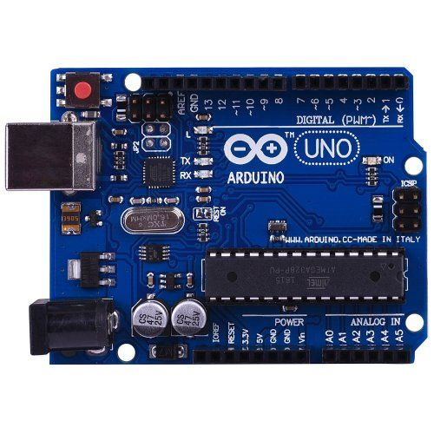

* MQ-7 | Carbon Monoxide Sensitive Gas Sensor:

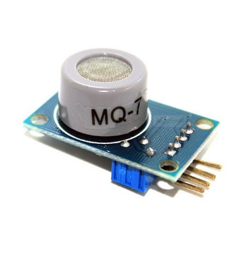

Adraxx MQ-7 MQ7 CO Sensor Module for Arduino is a gas Sensor for carbon monoxide detection. The sensor contains a Tin Dioxide (SnO2) sensitive layer (which has high resistance in air, but the resistance decreases as the CO concentration in ambient air increases). The sensor produces “arbitrary” values if used without calibration. Further details can be found in the data sheet.

* S/S Water Proof DS18b20 | Temperature Sensor:

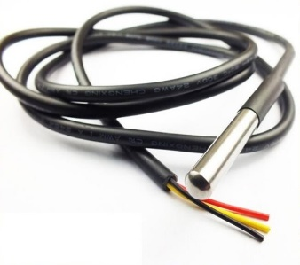

# S/S Water Proof DS18b20 Temperature Sensor Probe is a thermometer for the Arduino Uno and works on the principle of temperature dependent conductivity. This probe shall be present on board in-order to allow the user to maintain the 50°C temp. limit to ensure accuracy. Further details can be found in the data sheet.

# IIC I2C TWI Serial 2004 20x4 | LCD Module Shield:

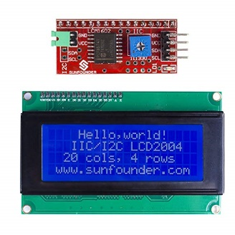

# IIC I2C TWI Serial 2004 20x4 LCD Module Shield shall be used as the on-board display for the sensor. This display has a 20x4 display and hence would be sufficient to display both the temperature and the concentration of the carbon monoxide. The display also has a potentiometer which can be used in order to adjust the display contrast. Further details are provided in the data sheet provided.

# Adafruit Datalogging shield:

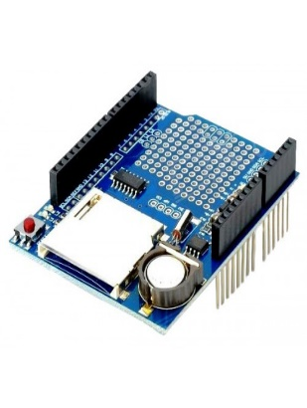

# Adafruit datalogging shield is a pre-assembles module that serves as an attachment to the Arduino-Uno board. The sheild comes with an SD card reader and writer slot, a RTC time-clock chip (for time keeping) and a recharging circuit pre-assembled on the board. The board requires a Lithium ion CR1220 batter to power the time clock chip when the device is on standby and not being powered.

Electrical components such as the battery, connection wires and resistor and such shall be used if required and hence are not necessarily included in the list above. The basic assembly of the circuit on-board shall be done as follows.

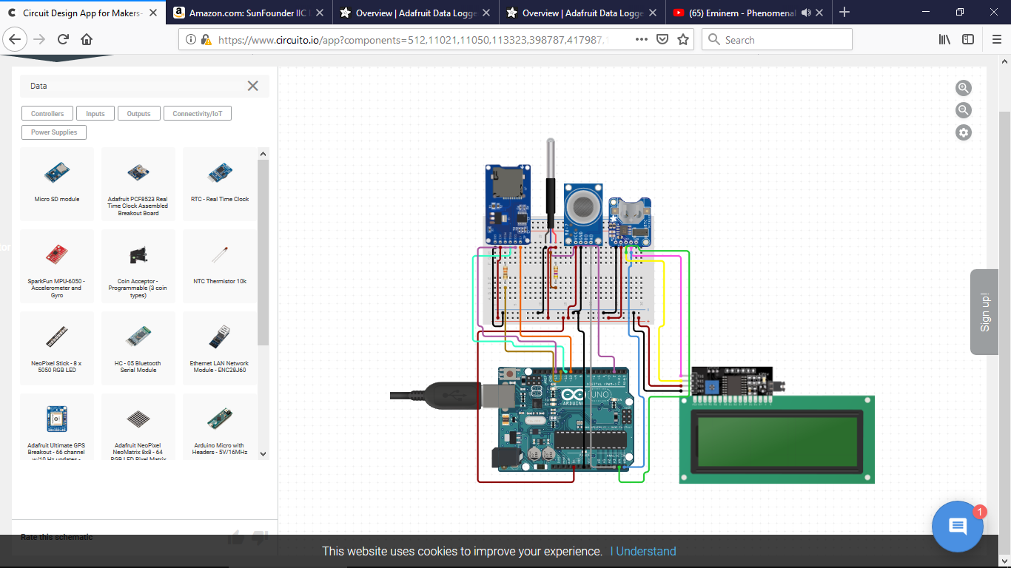

(*The design may be altered upon necessity)

CALIBRATION OF THE MQ-7 SENSOR FOR PPM UNIT MEASURMENT

The MQ-7 is a sensor that needs to be calibrated manually before it can display the concentration of CO in surrounding air. This requires the presence of another pre-calibrated sensor to calibrate the MQ-7 normally. But alternatively, the current passing through the sensor at 0ppm of CO can be measured in saturated inert atmosphere of any other gas. This shall provide a base reading and can later be used as a reference. Such an atmosphere may be crated in a contained flooded with pure inert gas (for e.g. N2).

CODING AND FLOWCHART

The code for the basic assembly of the above circuit in the Arduino IDE has been included as an attachment with. The code is subject to changes but the basic principle of the code shall remain unaltered. The flowchart for that code is as follows:

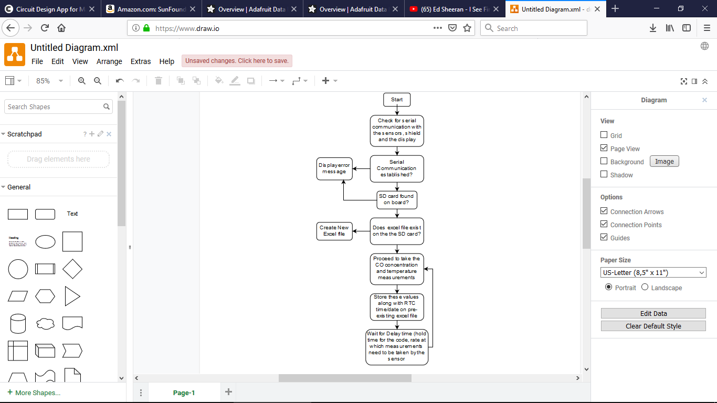

When the main power is switched on, the unit is activated. The Arduino Uno Board begins to run the burnt code repeatedly until it is switched off or the reset button is pressed. The Board establishes communication with the sensors, the LCD and the data-logger shield to receive, send and interpret the data from each of these components. If the same does not occur, the unit shall display an error message on the display. The unit after the communication established, begins to scan the SD card in the data-logger shield for an excel file. If unavailable, a file is created for data storage. The sensor then continually monitors its surrounding air for spikes or falls in the CO levels whereas the thermometer displays the ambient temperature values on the display for the user’s reference. The values once measured are stored on the excel files along with their serial number and the date and time of the measurements.

COST OF THE SENSOR ASSEMBLY

Though the prices of each of these components shall vary depending on the retailer, a reference price (from amazon.in) has been mentioned below along with the delivery charges.

|  |  |
| --- | --- |
| ITEM | PRICE ON amazon.in |
| Arduino Uno R3 | ATmega328P Microcontroller Board | Rs.425 + Rs.70 (delivery) |
| MQ-7 | Carbon Monoxide Sensitive Gas Sensor | Rs.250 + Rs.70 (delivery) |
| S/S Water Proof DS18b20 | Temperature Sensor | Rs. 205 + Rs.70 (delivery |
| Adafruit Datalogging shield | Rs.459 + Rs.70 (delivery) |
| IIC I2C TWI Serial 2004 20x4 | LCD Module Shield | Rs.230 + Rs.70 (delivery) |
| TOTAL | Rs.1919 [if all new components]  Rs.595 [if needed are new] |

The components that are highlighted are already owned by the department as a part of a previous project and hence may or may not be bought once again. Hence if all components are bought again, the price is Rs1919 whereas if only the unavailable components are bought, the price is Rs.595